The Clear Bag Policy
In an effort to improve the safety measures currently in place, Lamar will require all students to use clear backpacks. Students participating in an extracurricular activity are permitted to carry non-transparent bags to store items pertaining to their particular activity (i.e. band, athletics, etc.). Upon entry into the school, all extracurricular activity bags must be stored in lockers or designated areas. All bags are subject to search. A small non-transparent bag no larger than 4”x4” will be allowed for personal items inside the backpack. Additionally, the maximum size for non-transparent bags that are permitted to carry during the school day, such as lunch kits, and purses, will be 6” x 9”x5”.
FAQ:
Can backpacks be Mesh ?
No mesh backpacks are allowed
Will backpacks with padded backs be accepted?
Backpack must have clear visibility through all dimensions excluding the backpack bottom.
Are transparent colored backpacks allowed?
No. Colored, transparent backpacks are not allowed (see example). Only fully clear backpacks are permitted
Can the backpack have colored straps?
Yes. The backpack may have colored straps

Will athletic/spirit bags and instrument cases, which are not clear, be allowed on campus?
Yes, however, these bags must be stored as soon as the student arrives at school. They must be placed in lockers or secured in fine arts classrooms or athletic locker rooms as designated by school instructors.

Can the clear backpacks have mesh pockets?
Yes, mesh side pockets are allowed on the clear backpacks.
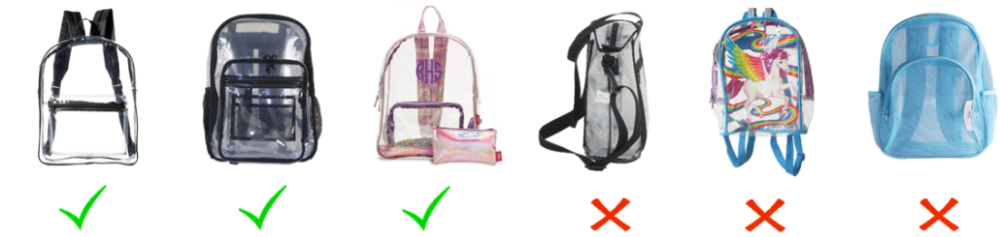

The Uniform Policy
Tops
- Students must wear a uniform white or navy blue polo shirt with “LAMAR IB” embroidery. These may be purchased in the school store or online through School Pay.
- Lamar spirit shirts may be worn on Fridays.
- All cold-weather clothing such as jackets, sweaters, hoodies, and sweatshirts must have the Lamar logo.
Pants, Shorts and Skirts
- Students may wear khaki uniform slacks, khaki shorts, khaki uniform skirts (unrolled, mid-thigh) or blue jean pants with no skin visible through the material. A plaid skirt option will be available for purchase from Academic Outfitters. Note: These items may be purchased at any nearby uniform store or department store that sells standard school uniforms. Leggings may be worn only under the uniform skirt.
- All pants, shorts, and skirts must be worn at the natural waist and be of proper length. All must fit properly and may not be excessively tight, loose or baggy.
Shoes
- Students must wear flat, closed-toe shoes with a secure back at all times, for safety.
- No slippers, house shoes, or shower shoes are allowed.
The following items are prohibited:
- head coverings of any kind, with the exception of coverings related to religious or medical requirements;
- accessories depicting or making references to drugs, alcohol, tobacco, vulgar or obscene language, sexual promiscuity, the occult, death, violence or gang-related activities may not be worn;
- spiked dog collars, spiked bracelets, linked chains (for wallets or necklaces);
- rosaries;
- metal rakes and combs are not allowed on campus;
- tatoos and henna markings with inappropriate or vulgar messages must be covered and not visible;
- expensive or irreplaceable jewelry should not be worn to school;
- any other clothing or accessory that causes a distraction to the school environment;
- alteration of the school uniform is not acceptable including, but not limited to hemming, writing/painting on, or any alteration of the school uniform.
Please note: Violations of the Lamar dress code will result in disciplinary action. Depending on the number of dress code offenses and the gravity of the offense, discipline may range from Level I to a Level III offense within the Student Code of Conduct. Courts at both the state and federal levels have recognized the rights of school officials to regulate standards of student dress and grooming.

